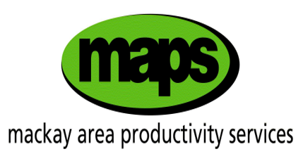

**Variety Information**



The information in this table is reproduced from the SRA Variety Guide with permission from SRA.

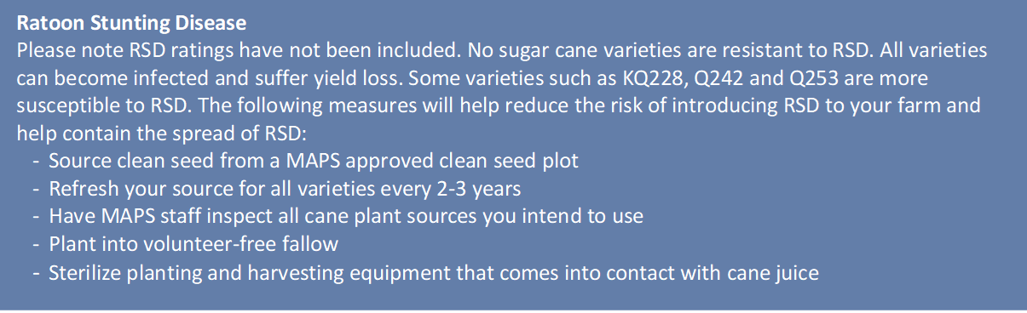

**MAPS Field Observations**

*The information in this table is from observations made by MAPS staff. It should be used as a guide only as varying conditions can impact variety performance.*

