What is a watercourse?
The maps produced below are from Qld Globe which is a publicly available internet mapping program https://qldglobe.information.qld.gov.au/ that uses the Vegetation management watercourse and drainage feature map (1:100000 and 1:250000) – Queensland except South East Queensland Version 5.0 as its data source. These maps and data with many other data layers are freely available to all members of the public. These data layer cleanly define a recognised watercourse across farming districts.

These watercourse are important when using agriculture chemicals as each individual label may refer to their use around a waterway or natural aquatic areas. These include non- wind buffers and Downwind buffers.
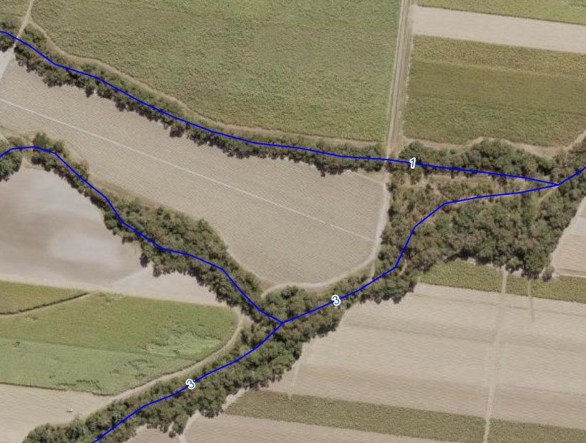

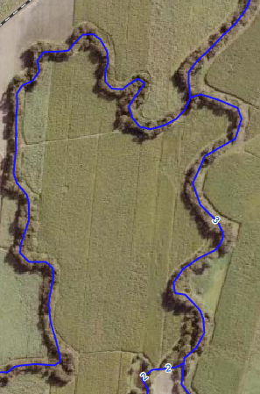

The Chemcial Usage (Agricultural and Veterinary) Control Regulation 2017 refers to a definition of a waterbody as:
A water body is—
(a) a natural channel, whether or not containing water; or
Examples—
a creek, river or stream
(b) an artificial channel, other than an irrigation channel or interrow furrow, whether or not containing water; or
(c) an area in which water is or can be contained by a dam or weir at full supply level; or
(d) a wetland.
Also, to remove any doubt, it is declared that if there is more than 1 natural channel within the outer limits of a water body, each channel is a water body.

However, a water body does not include—
(a) a drainage depression; or
(b) an effective vegetated treatment area; or
(c) an area in which water is, or can be, contained by a dam or weir that is on land owned or occupied by an entity other than the Commonwealth, the State or a local government; or
(d) an area inundated by water contained by a structure if the water is separate from and not flowing into a channel, dam, weir, or wetland to which subsection (1) or (2) applies.
Examples of a structure—
a recycling pit, retention dam or sediment trap

(4) In this section—
drainage depression means a channel, other than a drainage line or interrow furrow, that—
(a) is within a field or paddock in which sugarcane is grown but not at or near the perimeter of the field or paddock; and
(b) contains a permanent or intermittent flow of run-off; and
(c) can be easily crossed by an agricultural machine, including, for example, a planter.
full supply level, for a dam or weir, means the level of the water surface when the dam or weir is holding as much water as it can hold while not affected by flood.

What is the edge of a water body
- The edge of a water body is the place at which the bank of the water body meets the adjacent flood zone.
- However, if there is no obvious place under subsection (1), the edge of the water body is the part of the bank of the water body where the downward slope toward the bed of the water body is more than 2%.

